TWO FACTOR AUTHENTICATION:
What is two factor authentication????????
- Two-factor authentication is a security method that adds a second layer of identity verification. Instead of relying on just a password, 2FA requires you to confirm your identity using two distinct factors. This reduces the risk of unauthorized access, even if a password is compromised.
How it works???
The 2FA process it adds a real time verification step to standard login workflow.
- We enter our username and password on any site or apps.
- The server recognizes the password and request the second factor.
- We complete the 2nd factor by entering a otp , or a hardware key or approve a push notification.
- If the server approves or validates this second factor , you can access the app or the site.

Why it exists??
Basically the reason 2FA exists is to stop unauthorized access, particularly in cases where passwords have been leaked or stolen via data breaches. It exists to
- Prevent account takeover
- To protect against phising
- And to reduce automated attacks
Passwords alone are very weak and they are not very sufficient nowadays to secure digital accounts particularly in this big year of 2026 where it is really easy to steal, guess or reuse the same passwords.
Phishing and social engineering, credential stuffing, data breaches, ai-powered attacks, malwares and keyloggers are few examples of the cyber attacks we can face.
Types of 2FAs:
- SMS OTP Authentication: it authenticates the user through a one time code(OTP) send by sms or emails.
- 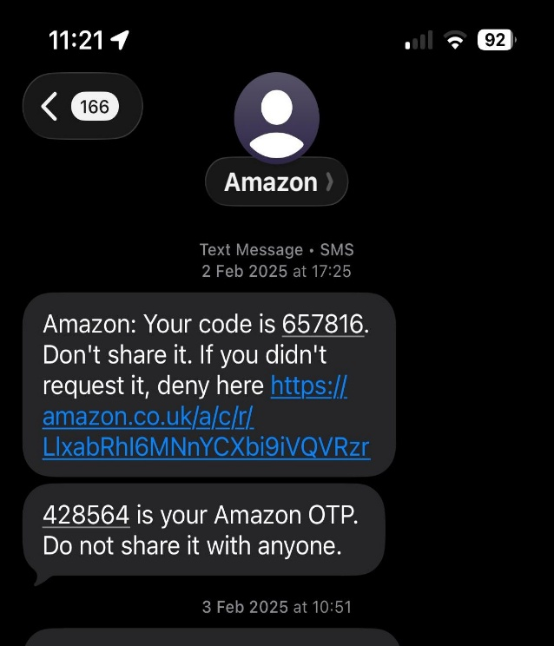

Figure 1example of otp

- authenticator Apps: the authenticator apps enhance security over sms, with many providing encrypted backups and multi-device syncing. 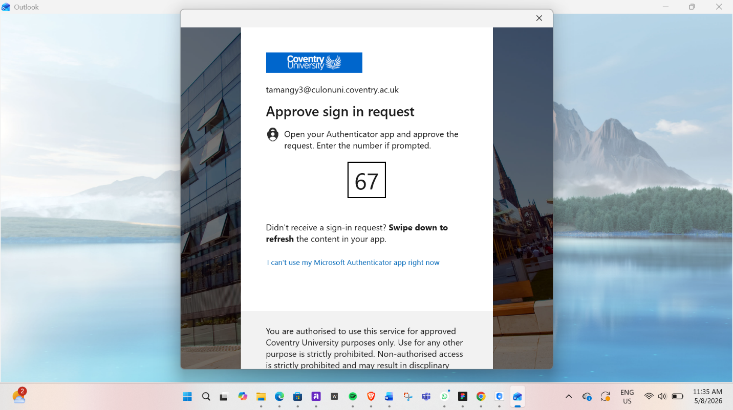
Figure 2 example authenticator app
- Email verification: 2FA email verification examples include concise, time-sensitive codes or magic links sent to a user’s registered email after they enter their password

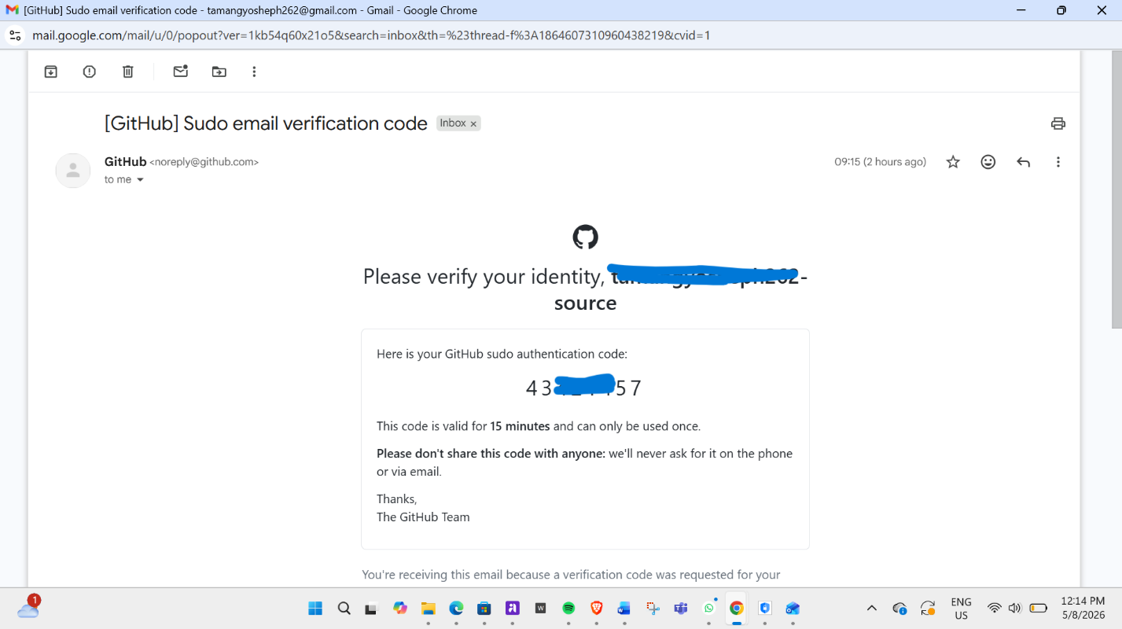
Figure 3 example of email verification
- Push notification: it provide a secure, one tap method to authorize logins by sending an instant prompt to a users mobile device.
- 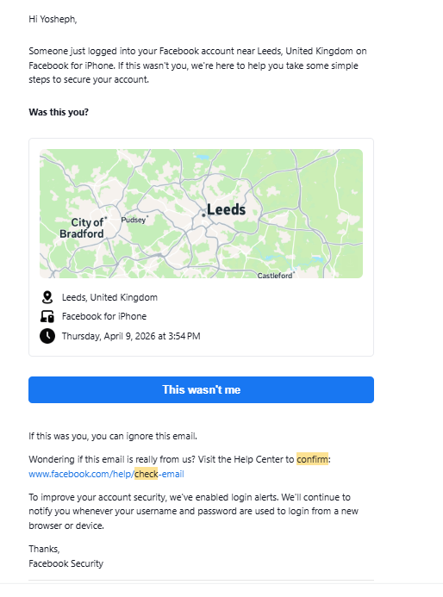
- Biometrics: Biometric 2FA (Two-Factor Authentication) uses unique physical or behavioral characteristics, "something you are" as the second layer of security after a password. Common examples include fingerprint scans, facial recognition (FaceID), iris scans, and voice recognition. These methods provide high security and convenience for accessing devices and apps

Comaprision between 2FA methods
2FA method | How it works | Weaknesses | Real-life use
SMS OTP | Code send by text message | SIM swap scams, weak signals | Instagram, banking apps
Authenticator apps | App generates login code | Phone loss can lock users out | Gmail, discord, GitHub
Email verification | Code link send to email | Unsafe if email is hacked | Password resets, logins
Push notifications | User approves login | MFA fatigue spam attacks | Microsoft, banking apps
biometrics | Fingerprint or face ID login | Sensor errors, privacy concerns | Smartphones, banking apps

